**CSB 304: Computer Networks**

**PROJECT REPORT**

**Date Assigned: 17/11/2023 Date Submitted:29/11/2023**

**Submitted By:**

**Name: Dhruv Tyagi**

**Roll No: 211220018**

**Branch: CSE**

**Semester: 5th Sem**

**Group: 2**

**Submitted To: Dr. Jyoteesh Malhotra**

Department of Computer Science and Engineering

**NATIONAL INSTITUTE OF TECHNOLOGY DELHI**

2023

**INDEX**

|  |  |  |
| --- | --- | --- |
| **S.NO** | **CONTENT** | **Page** |
|  |  | **No** |
| 1 | Title of the project | 3 |
| 2 | Abstract | 4 |
| 3 | Description | 4 |
| 4 | Layout | 12 |
| 5 | Results | 18 |
| 6 | Conclusion | 19 |

Green Glow Gardens: **Illuminating Sustainable Agriculture in a Smart Greenhouse Oasis**

**(A Smart Greenhouse System Using Cisco Packet Tracer)**

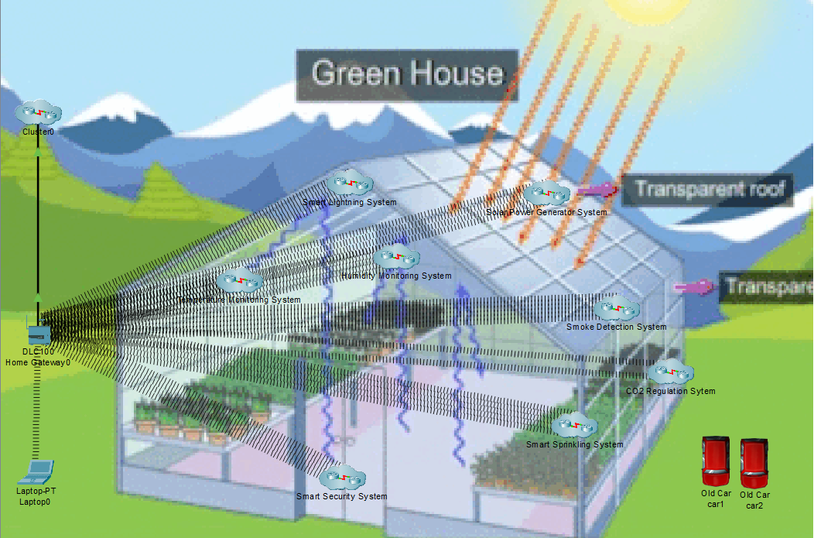

Abstract

The Smart Greenhouse system, named "GreenGlow Garden," addresses the limitations of traditional greenhouse management by leveraging Internet of Things (IoT) technology. It aims to optimize plant cultivation through remote monitoring and control of critical environmental factors. By integrating sensors for temperature, humidity, fire safety, CO2 levels, and soil moisture, the system ensures precise conditions for plant growth. This not only enhances resource efficiency and crop yield but also allows for real-time decision-making, risk mitigation, and adaptability to changing environmental conditions. The inclusion of solar cells contributes to sustainability, aligning with the growing need for eco-friendly agricultural practices. In essence, the Smart Greenhouse system provides a technologically advanced and data-driven approach to modernize and improve greenhouse operations.

Description

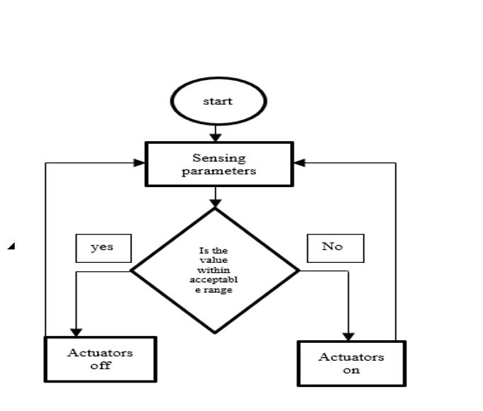In this project, we are implementing the greenhouse setup using cisco packet tracer. A network is formed by connecting the sensors .

**FLOW CHART:**

Fig3 shows the general flow chart of the methodology used in this project. The same procedure is used for all the systems used in this design. First the sensors sense their respective parameters and the values sensed are converted into the appropriate format which are then fed to the actuators. The actuators are activated based on the input given following predefined conditions.

Fig1: Flow chart

In the innovative Smart Greenhouse system, known as "GreenGlow Garden," various interconnected subsystems(clusters) work synergistically to revolutionize traditional greenhouse management.

These are as follows:-

1. **Temperature Monitoring System:**
   * Regulates and maintains the greenhouse temperature within optimal ranges to support plant growth.
2. **Humidity Monitoring System:**
   * Monitors and adjusts humidity levels to create an ideal atmosphere for plant development.
3. **Smoke Detection and Fire Safety System:**
   * Detects and responds to potential fire hazards, ensuring the safety of both plants and infrastructure.
   * Monitors for the presence of smoke within the greenhouse, triggering rapid responses to mitigate potential fire risks and protect plant life.
4. **CO2 Detecting System:**
   * Monitors carbon dioxide levels crucial for photosynthesis, adjusting ventilation to optimize CO2 concentration.
5. **Smart Sprinkling** **System:**
   * Assess the moisture content in the soil to facilitate efficient irrigation, preventing overwatering or drought stress.
6. **Solar Power Generation System:**
   * Harnesses renewable energy from solar cells to power the smart greenhouse, promoting sustainability and resource efficiency.
7. **Smart Security System:**
   * Incorporates security measures to safeguard the greenhouse from unauthorized access, theft, or vandalism, ensuring the protection of valuable crops and equipment.
8. **Smart Lighting System:**
   * Utilizes intelligent lighting controls to supplement natural light and optimize the light spectrum for plant growth, enhancing photosynthesis and productivity.

**1. TEMPERATURE MONITORING SYSTEM:**

* + Temperature monitoring system contains temperature sensors, thermostats, heating elements, and cooling elements.
  + Temperature sensor keeps a check on the temperature of the environment and displays the value on a connected LED or monitor. The temperature sensed by the sensor is converted into appropriate form and is given as input to the Thermostat .
  + Thermostat is used to control temperature in a greenhouse based on the temperature sensed by the temperature sensor. Heater is activated when the temperature falls below the preset value and cooler is activated when the temperature is greater than the preset value. The thermostat is in an off state when the temperature inside the greenhouse is in the acceptable range for the positive growth of plants .

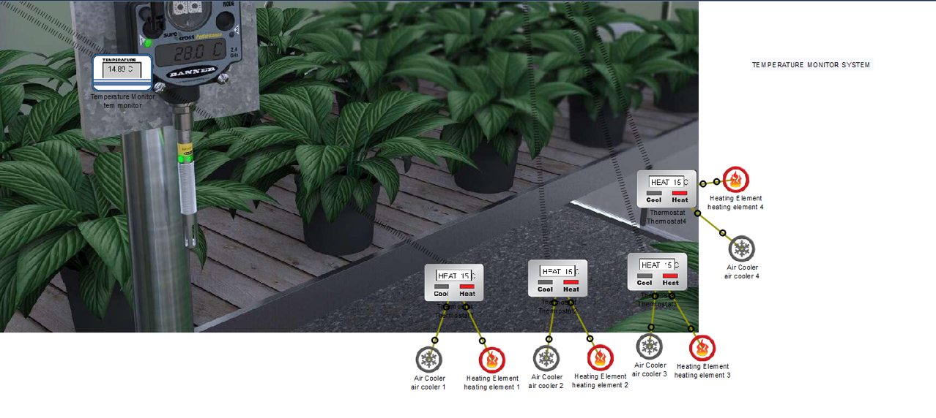

**2. HUMIDITY MONITORING SYSTEM:**

* + Humidity monitoring systems contain humidity sensors, humidifiers.
  + Humidity sensors measure the amount of water (humidity) content present in the air. Humidifier is used to maintain the moisture content in the air. Humidifier is activated when the humidity percentage in the greenhouse falls below the desired value.

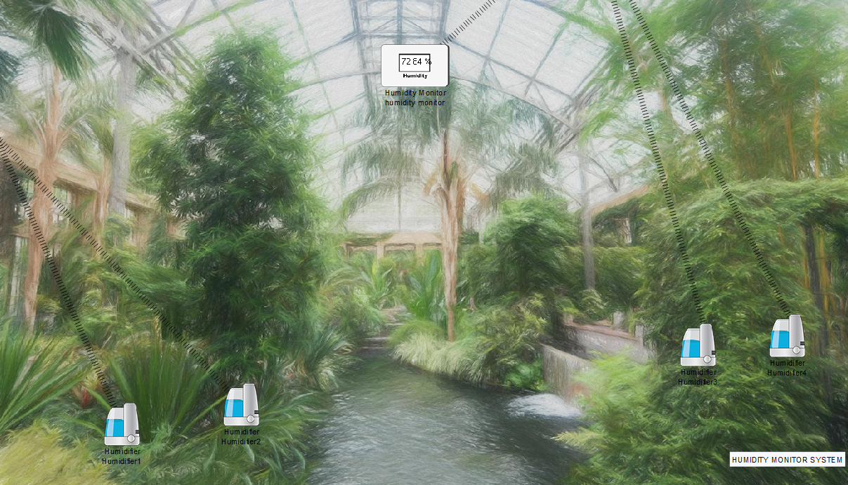

**3. SMOKE DETECTION AND FIRE SAFETY SYSTEM:**

* + Smoke detection system contains a smoke detector, fire sprinkler, Siren. A smoke detector is a device that senses the presence of smoke .As soon as the fire is detected a message is delivered to the security panel and the fire alarm is activated.
  + When there is any fire emergency, the sprinkler will be activated by itself as soon as the smoke detector detects smoke.

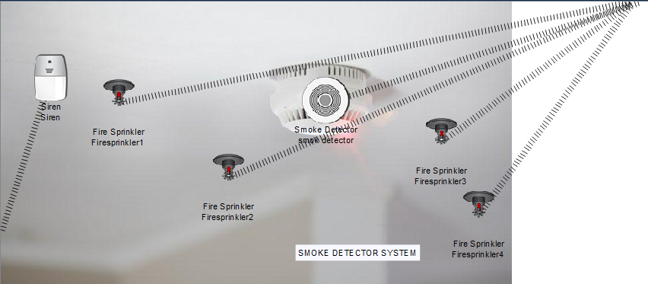

**4. CO2 DETECTING SYSTEM:**

* + The CO2 detecting system contains a CO2 detector, exhaust fan. Carbon dioxide detector is a device which senses the concentration of carbon dioxide in the atmosphere.
  + There are basically two types of CO2 detectors, IR and chemical sensors. CO2 plays an important role in the growth of plants. It is necessary to maintain the CO2 content in the greenhouse.
  + Hence the C02 sensor is used to monitor the CO2 levels. when CO2 detected in greenhouse is high with respect to desired value exhaust fan is operated at high speed and when CO2 detected with respect to acceptable value is moderate exhaust fan is operated at low speed and when CO2 is within the acceptable the range exhaust fan is turned off.
  + Old car which generates a lot of CO2, CO and contributes to pollution is used to produce CO2 to check for proper working of the designed system.

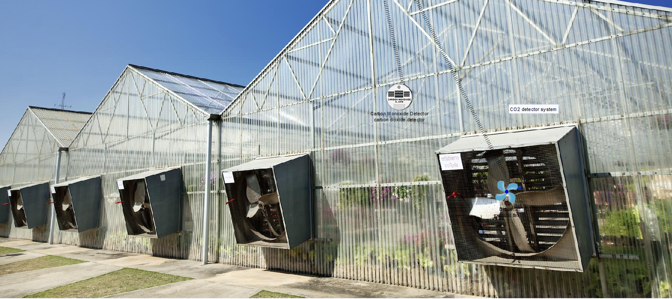

**5. SMART SPRINKLING SYSTEM:**

* + Sprinkling system contains a water level monitor, lawn sprinkler.
  + Water level monitor measures the water content present in soil which is the indication for moisture content in soil. Particular amount of moisture has to be maintained in soil for healthy plant growth.
  + When the moisture content falls below the preset value water sprinkler is activated.

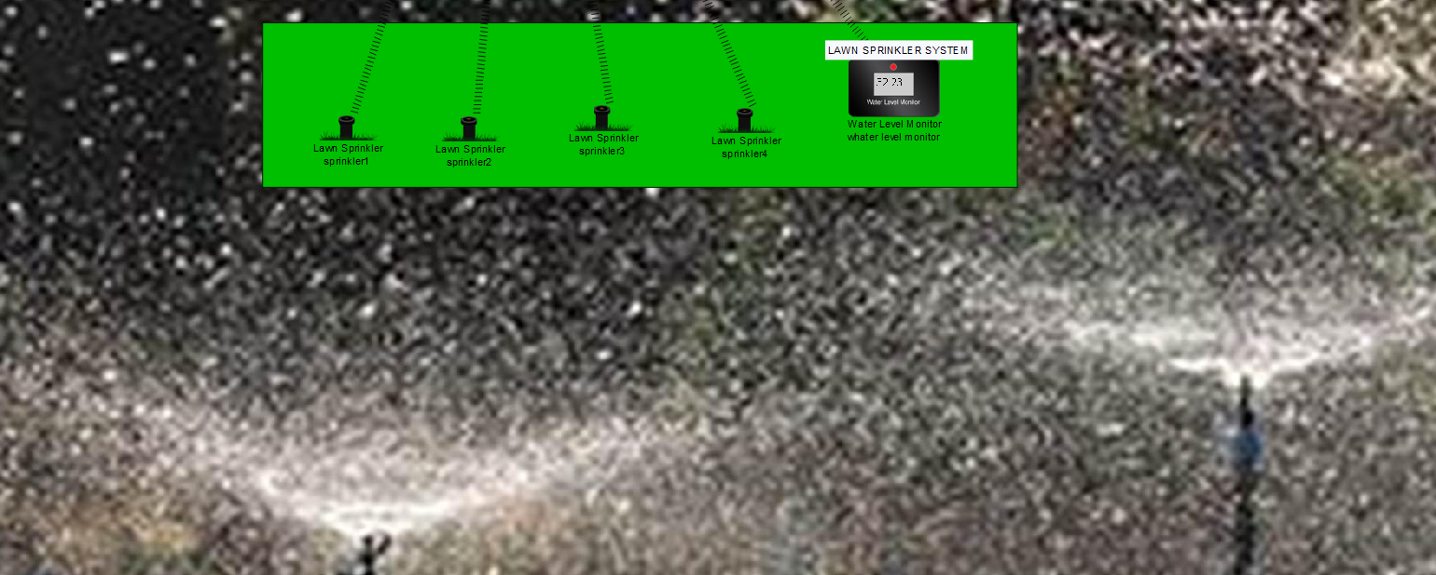

**6. POWER GENERATION SYSTEM:**

* + Power Generation System contains a solar panel, power meter, and battery. A solar panel converts sunlight into electricity by using the appropriate technique.
  + The power produced by the solar panel can be known using the power meter (which measures power across the device to which it is connected). The electricity generated by the solar panel is converted and stored in a battery which is connected to all the devices.
  + This project uses solar cells to supply energy for all the devices which is also eco-friendly. In this system we have connected an electric gadget to battery. When battery saves the energy as much as the set value(30%) then electric gadget will get on.

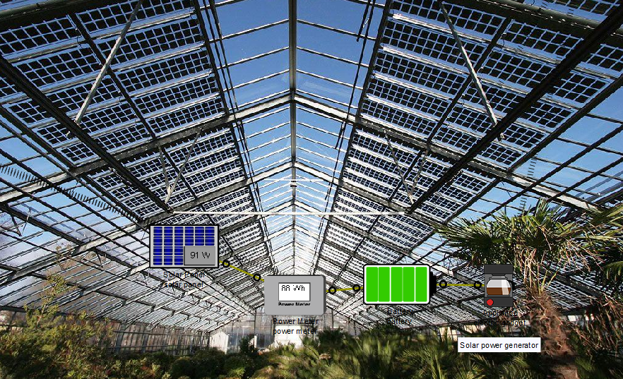

**7. SMART SECURITY SYSTEM:**

* + Smart Security System contains RFID valid card, RFID invalid card and RFID reader.
  + If the RFID reader reads a valid card then the door will unlock and siren is off, else if the motion detector is on and the RFID reader reads it invalid then the door will be locked and the siren will get on. Webcam is also on for all time.

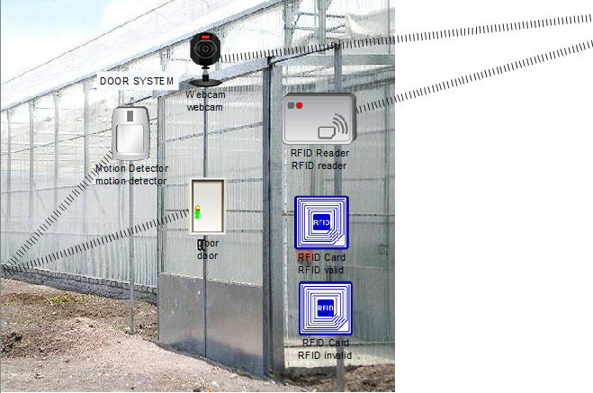

**8. SMART LIGHTNING SYSTEM:**

* + This project uses a smart lighting system to maintain the lighting arrangements.
  + If RFID id reader reads valid card and door will get upon and lamp will get on.
  + When a person enters in the green house then one lamp will get on and according to the need we can control other lamps by using a smartphone.

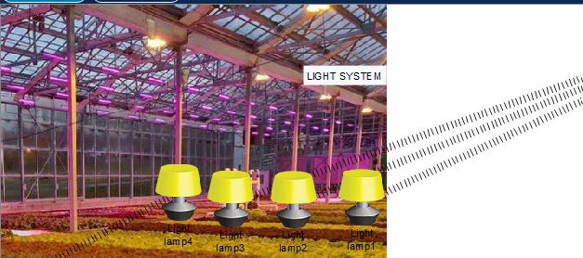

Layout

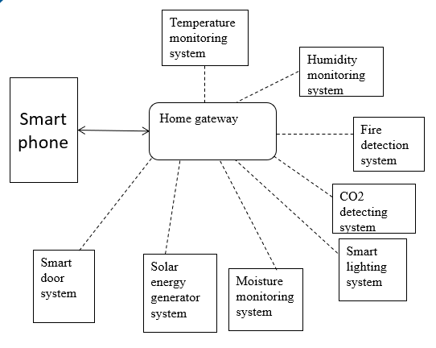

**Fig2** shows the block diagram of Smart greenhouse based on IoT in Cisco packet tracer. The block diagram contains temperature monitoring system, humidity monitoring system, fire detection system, co2 detection system, smart lighting system, moisture monitoring system, solar energy generator system, smart door system . All the devices are connected using the internet. A smart phone is used to monitor the devices in the greenhouse. Wireless devices are used to implement the designed system

Fig 2: Block Diagram

**Layout Description: GreenGlow Garden Smart Greenhouse System**

1. **Subsystem Clusters:**

a. **Environmental Monitoring Cluster:**

* + Temperature Monitoring System
  + Humidity Monitoring System
  + CO2 Detecting System
  + Smart irrigation System

b. **Safety and Security Clusters:**

* + Smoke Detection and Fire Safety System
  + Smart Security System

c. **Resource Efficiency Clusters:**

* + Solar Power Generation System
  + Smart Lighting System

d. **Communication Cluster:**

* + Laptop (connected via LAN)
  + Home Gateway

e. **IoT Backbone and Server Cluster:**

* + IoT Backbone
  + DNS Server

1. **Connectivity Overview:**
   * All subsystem clusters are interconnected through a Local Area Network (LAN) facilitated by the laptop and home gateway.
   * The laptop serves as the central monitoring and control hub for the greenhouse subsystems.
2. **User Interface and Remote Access:**
   * The laptop provides a user-friendly interface for real-time monitoring and control of the GreenGlow Garden subsystems.
   * A dedicated smartphone application enables users to remotely access the system from the comfort of their homes.
3. **IoT Connectivity:**
   * The IoT Backbone facilitates communication between the GreenGlow Garden subsystems and the smartphone.
   * A DNS server ensures seamless domain-based access for the smartphone application to connect with the GreenGlow Garden IoT devices.
4. **User Experience:**
   * Users can view and control the GreenGlow Garden system remotely through the smartphone application.
   * The interconnected clusters ensure that environmental conditions, safety measures, and resource usage are efficiently monitored and managed.

This layout description provides a clear overview of the clusters, connectivity, and user interfaces within the GreenGlow Garden Smart Greenhouse System. It highlights the integration of IoT technology, the role of the laptop as a control hub, and the user-friendly experience facilitated by the smartphone application for remote monitoring and control.

**Fig3** shows the monitoring of devices in the greenhouse using smartphones. The values sensed by sensors and the status of actuators can be monitored in smart phones.

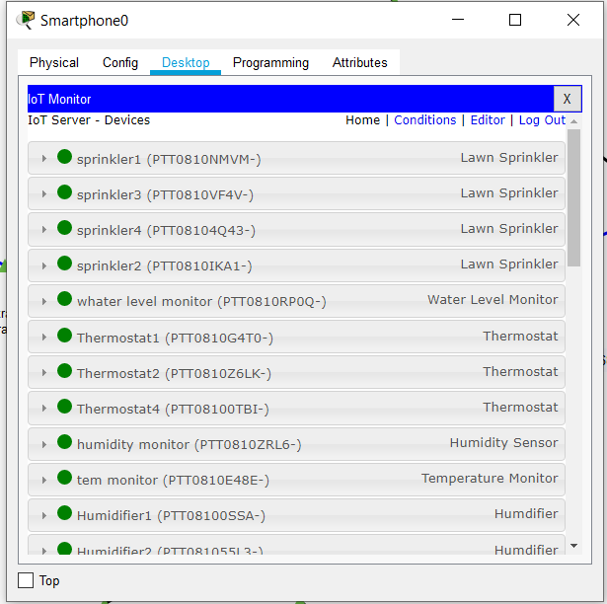

Fig3: smartphone monitoring



Fig4: Smart Greenhouse System having 8 clusters

**Connections and assigning IP addresses:**

**5.1 Smartphone connection with home gateway**

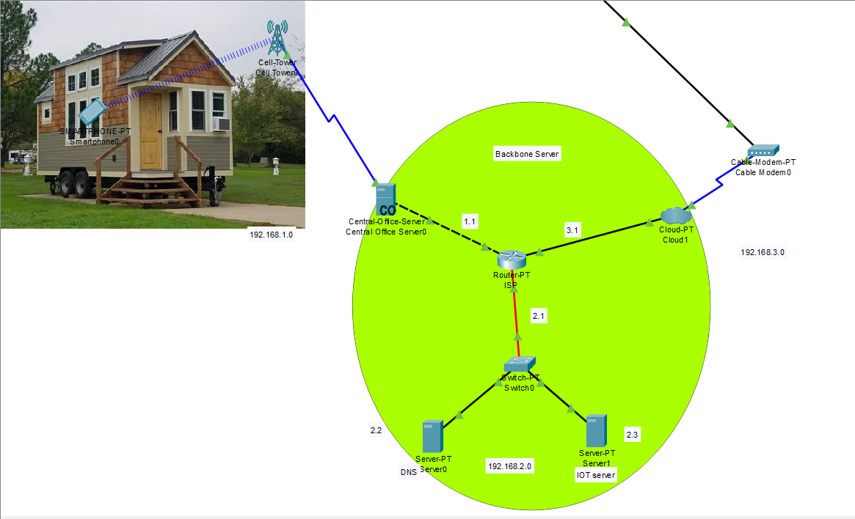

**5.2 Assigning ip address to central office server:**

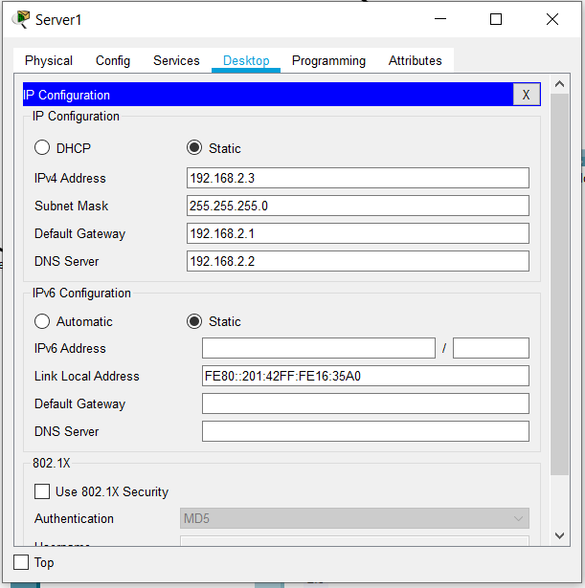

**5.3 Assigning ip address to IOT server:**



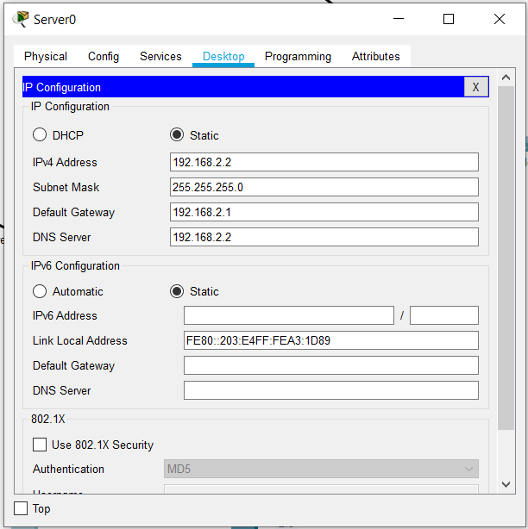**5.4 Assigning ip address to DNS server:**

Results

The implementation of the GreenGlow Garden Smart Greenhouse System has yielded significant improvements in the monitoring, control, and efficiency of greenhouse operations. The integration of various subsystems, including environmental monitoring, safety and security measures, resource efficiency, and IoT connectivity, has resulted in the following notable outcomes:

1. **Optimized Environmental Conditions:**
   * The Temperature Monitoring System, Humidity Monitoring System, CO2 Detecting System, and Smart Sprinkling System collectively contribute to creating and maintaining optimal conditions for plant growth. This has led to improved crop yields and enhanced overall plant health.
2. **Enhanced Safety and Security:**
   * The Fire Safety System and Smoke Detection System have proven effective in detecting and mitigating potential hazards, ensuring the safety of both plants and infrastructure.
   * The Smart Security System has provided additional protection against unauthorized access and theft.
3. **Resource Efficiency and Sustainability:**
   * The integration of Solar Cell Integration and Smart Lighting System has increased resource efficiency by harnessing renewable energy and optimizing light conditions.
   * This not only reduces operational costs but also aligns with sustainable agricultural practices.
4. **Effective Communication and Monitoring:**
   * The interconnected subsystems, facilitated by a Local Area Network (LAN) and home gateway, enable centralized monitoring and control via a dedicated laptop interface.
   * Users can efficiently manage the greenhouse environment from a single access point.
5. **Remote Access and User Convenience:**
   * The IoT Backbone and DNS Server allow users to access and monitor the GreenGlow Garden system remotely through a dedicated smartphone application. This has provided users with unprecedented convenience and flexibility in managing the greenhouse from afar.

Conclusion

In conclusion, the GreenGlow Garden system not only showcases the capabilities of modern technology in agriculture but also sets a precedent for the adoption of smart greenhouse systems to meet the demands of a rapidly evolving and technologically driven agricultural landscape. The successful integration of various subsystems demonstrates the feasibility and potential impact of smart agriculture solutions in enhancing both productivity and sustainability.